A Great Big Read – KS1
Ask your family and friends if they would like to sponsor you to read and respond to books. Each activity has a suggested sponsor value but people can donate whatever they like for you to complete each task.
Once completed – tick off and date to show you’ve done it and don’t forget to collect the money in!
Make a list of as many nouns as you can from the book | Draw a picture of your favourite part of the book and write a sentence about what is happening.  Say why you chose this bit. | Enjoy reading a rhyming book – can you find any more rhyming words? | Draw a picture of one of the characters | Make a list of places you can find reading – try to find as many as you can
Suggested sponsor Value: £1 | Suggested sponsor Value: £1 | Suggested sponsor Value: £3 | Suggested sponsor Value: £1 | Suggested sponsor Value: £1
Sponsored By: | Sponsored By: | Sponsored By: | Sponsored By: | Sponsored By:
Make a list of adjectives (describing words) that the writer uses to describe places in the story.  Which is your favourite? | Design a new book cover | 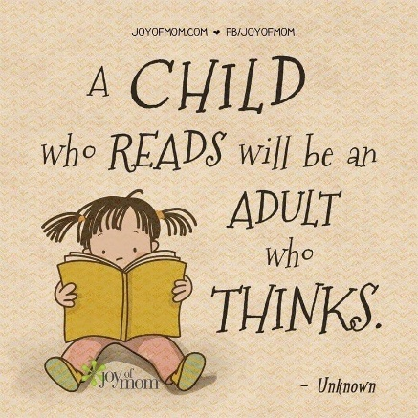 | Which character in this book would you most like to be?  Explain your answer. | Find as many different words as you can that mean ‘BIG’
Suggested sponsor Value: £1 | Suggested sponsor Value: £1 |  | Suggested sponsor Value: £1 | Suggested sponsor Value: £1
Sponsored By: | Sponsored By: |  | Sponsored By: | Sponsored By:

Use program  WordArt.com - Word Cloud Art Creator  to create a collage of words and/or  pictures to go with your book.   | Find 5 verbs that show what a character is doing | Dress up as your favourite character from a book | Re-tell the story to someone else (maybe this could be videod | Read a non-fiction book and tell someone what it’s about
Suggested sponsor Value: £2 | Suggested sponsor Value: £1 | Suggested sponsor Value: £3 | Suggested sponsor Value: £1 | Suggested sponsor Value: £1
Sponsored By: | Sponsored By: | Sponsored By: | Sponsored By: | Sponsored By:
Write down or tell someone the best bit of your book – why did you choose this bit? | Draw and label a picture of one of the settings | Make up three questions you could ask someone about the book  ??? | 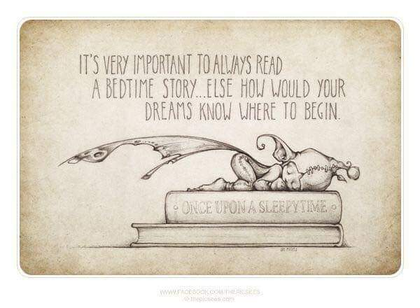 | Find words that show that a character is happy  
Suggested sponsor Value: £1 | Suggested sponsor Value: £1 | Suggested sponsor Value: £3 |  | Suggested sponsor Value: £1
Sponsored By: | Sponsored By: | Sponsored By: |  | Sponsored By:

