Oxenhope C of E Primary School – Long Term Plan
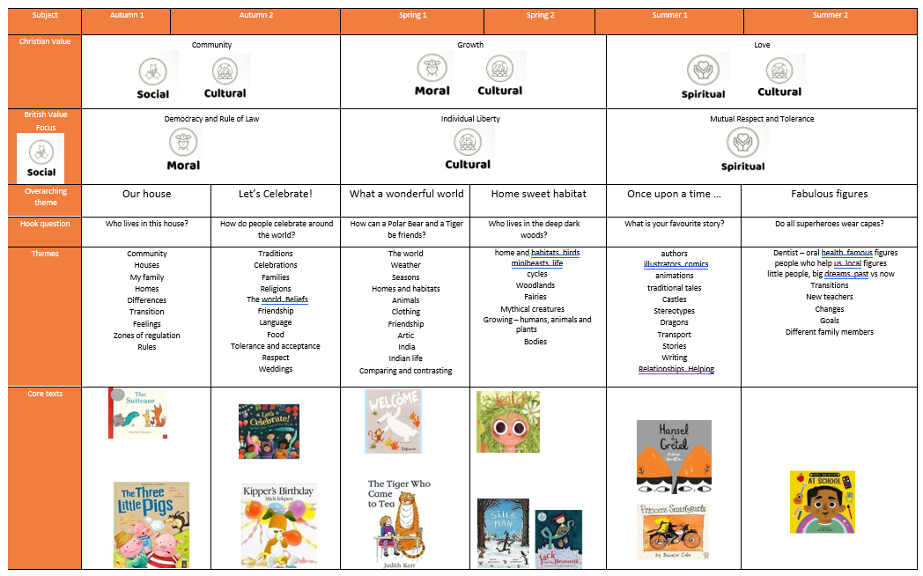

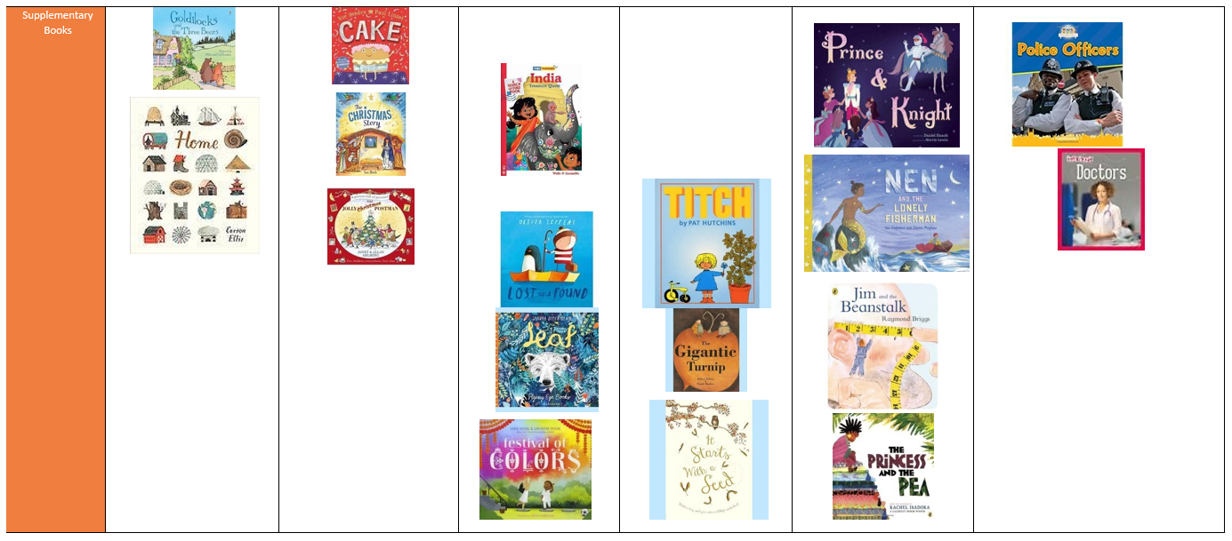
More Supplementary Books | 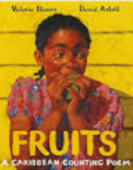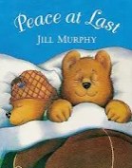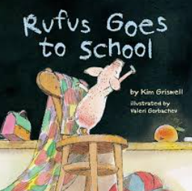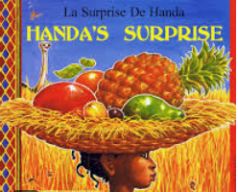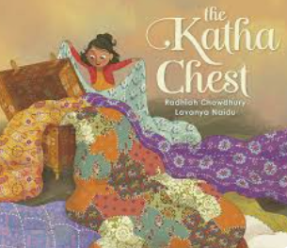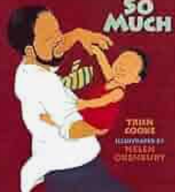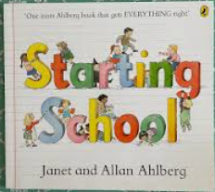 | 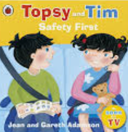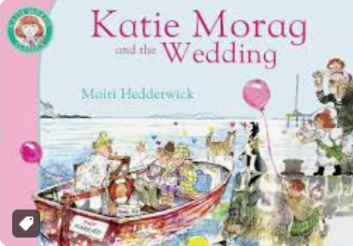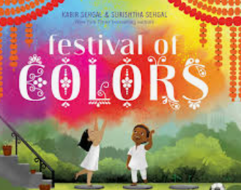 | 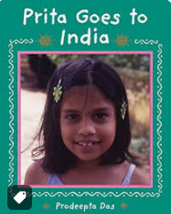  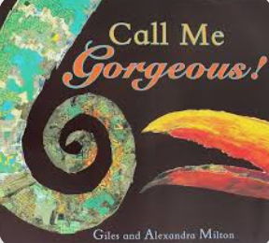  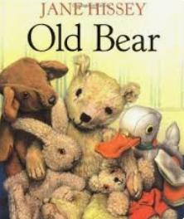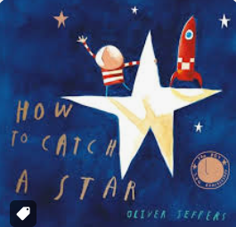 | 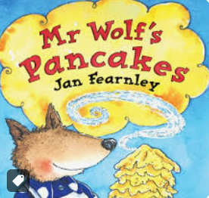  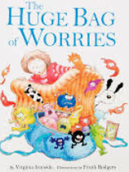  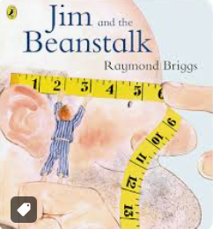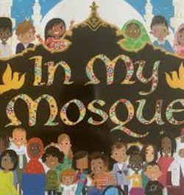  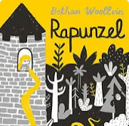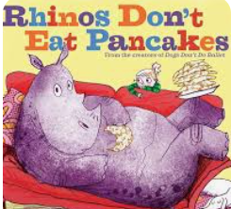 | 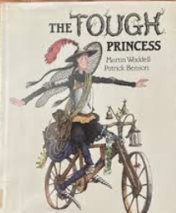  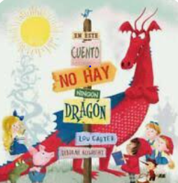  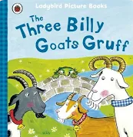  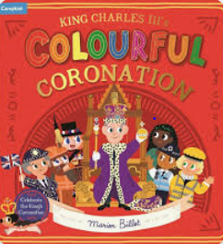 | 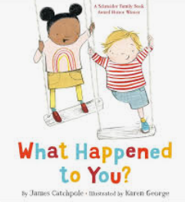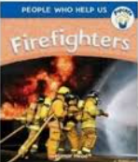  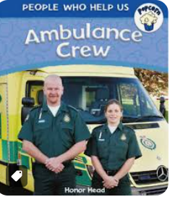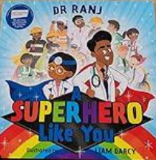  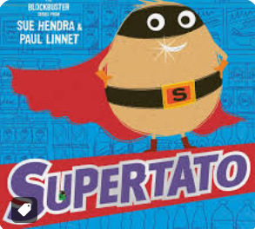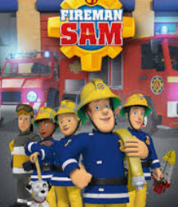
Special Weeks | Environment Week  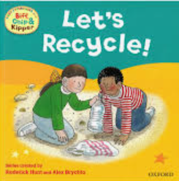 | Anti Bullying Week  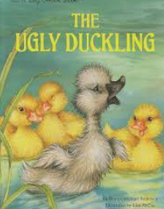 | Diversity Week  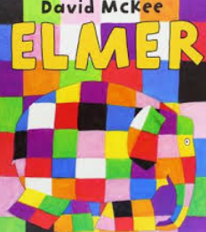 | Dress to Express  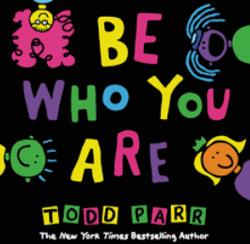  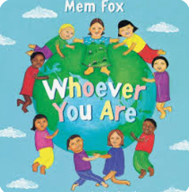 | Healthy Mind and Body  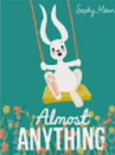 | Transition  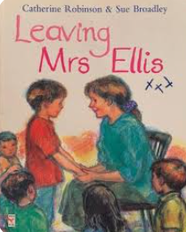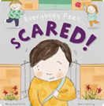

English | Begin to write their own name  Label things in home | Non fiction  Bonfire night – senses  Instruction writing  Diwali  Birthday cards  Kipper’s Birthday  Rama and Sita  The Scarecrow’s wedding  Invitations  Nativity story / sequencing | Describe settings  Prediction – what might happen? Why do you think that?  Creative writing  Lists  Story maps  Invitations  Ordering sentences  Sequencing the story | Instructions – pancake day  Character descriptions  Speech writing  Facts / phrases  Write labels  Adaptations (change the ending)  Create their own world at the top of beanstalk  Letter writing | Prediction  Comparing stories  Write from characters point of view  Holding a sentence and writing it  Farm leaflet / map / labels / recount  Missing posters  Description of setting  Instructions  Story map  Story adaptations | People who help us  Thank you messages / notes / cards / letters  Questions  Recounts  Grouping sentences  instructions

Maths | Baseline  Counting out smaller amounts from larger amounts  Recognising and working within (bonds) numbers 1-5  1 more than up to 5  Sorting  Comparing amounts  Capacity  Comparing length  Triangles, circles, squares and rectangles | Counting back from 5  1 less than  Doubles to 5  Symmetry  Finding half  Subitising  Counting on and counting back along a number line  Carry on a repeating pattern  Shapes in the environment / select for a purpose  Part whole models  Night /day | Properties of shape / comparing shapes  Sorting / grouping  Compare length  Recognising and working within numbers 6-10  Bonds to 10  1 more than to 10  Subitising to 10  Doubles to 10  Adding within 10  Counting forward songs  3d shapes | Counting backward songs  Numbers 6-10  Counting back / 1 less than  Finding half of numbers to 10  Subitising to 10  Rotating shapes / manipulating shapes  Bonds to 10 (2 and 3 parts)  Explore hight, length and time  Odd and even numbers | Doubles and halves  How many now?  Adding and subtracting small amounts  Pairs / count in 2s  Comparing numbers  Making connections  Repeating patterns – extend, create their own, spot the mistake  Odd / even numbers  Problem solving  Patterns beyond 10  Build numbers to 20 and beyond  2d/3d shapes | Part whole  Count beyond 10  Adding and taking amounts  Explore sharing and grouping  Equal and odd  Number sentences  Maps with models  Positions  Number formation  Problem solving  Capacity  Consolidating  interventions
Science | Healthy Lunch boxes  Classroom / home environment  Keeping healthy by exercise  Building houses with different materials  Signs of autumn  Taste fruit test  habitats | Keeping safe / bonfire night  Describe using Senses  Tasting different foods  Explore / investigate  Changes in weather / materials – ice  Ask questions | Hot and cold countries – describe using senses  Habitats  Changes in state – melting ice / winter signs  Select appropriate materials to make a boat / float / sink  Predict / investigate | Signs of spring  Baby animals  Planting seeds making predictions, noticing / observing  Life cycles  What do plants need to live?  Recording findings | Daily weather recording  Habitats  Noticing / observing  Predicting  Recording changes | Weather types  Signs of summer  Exercise (sports day)  Investigate / predict – how to keep the water warm  Materials / appropriate for task  Harvest planted vegetables and eat them
Art / DT | To sketch and paint their house with ready made poster paint  Use large scale blocks /blankets / loose parts to build houses outdoor – it must have a roof  Joining  Observational painting  Printing | Printing fireworks  Clay – sculpt diva lamps  Learn about Hundertwasser and experiment with shades of green  Salt dough decoration  Cut out and assemble model | Make a moving boat picture  Design/make a junk model boat  Create work based on Matisse  Colour match/detail  Hot / cold colours  Design their own animal | Learn about Van Gogh and colour match the sunflowers  Join leaves to branches using different techniques  Large art using construction materials  Colour mix  Fuit/salad kebabs  Natural object pictures | Design and make a bed from junk  Observational drawing of animals  Learn about illustrator Deborah Allwright  Design and make healthy cookies  Repeating pattern dragons | Design and make a moving vehicle  Appropriateness of material  Paint self portrait  Draw the view of Oxenhope – perspective / lines / shape and size  Large scale weaving  Design and make a super hero cape for a potato out of different materials

History | Sort objects from the home corner into past / present  Discuss photos similarities / differences  Draw members of you family – old / young  Photo | Learn about Guy Fawkes and Rememberance Day  Remember celebrations from their own history  Birthdays – 1 Yr older  Stories from the past – Nativity  Christmas traditions  Age of buildings | Discuss memories and older relatives  Discuss past holiday photos – how holidays have changed.  Learn about Ghandi  Use time lines and chronolgies to sequence events  Have the polar ice caps changed over time? | Look at baby photos – how have they changed? What can you do now that you couldn’t before?  Sequence events – what happened a long time ago? What happened yesterday?  Find out about people our houses are named after. Easter story from the past. Look at changes in plants. | Sort words into past and present  Learn about Saint George  Learn about the royal family – who everyone is and their roles.  Compare the jobs of princesses in real like and those from story books. What are the similarities and differences? | Learn about different artefacts from the past and their uses – Posser / washboard / slate etc and match them to their current counterparts. Bring in old items from home to talk about.  Learn about the history of the RNLI  Learn about Blackbeard.  Learn about Mary Seacole  What have you learnt this year that you didn’t know at the start of the year? How have you changed this year?
Geography | Who lives in my house – talk about families  Look at pictures from Haworth / Oxenhope draw map from JB’s house to school, include key features. Children to draw their own journey  Map of their bedroom using positional language. Birds eye view of playground. Draw map of how to get to the nature area | Locate London  Locate India  Compare India to Oxenhope (Diwali)  Where have you been on holiday? Locate countries – track santa’s journey – create material map / blue / green / white  Plot Mary and Joseph’s journey  Compare different houses - discuss | Signs of winter. How has the landscape changed? Create hot/ cold landscapes  Compare Artcic / Antarctica. Hot/ cold holidays – clothing / animals. Eddie the Penguin –melting ice caps –eco awareness  Learn that we live on an island. Look at features of places / towns / cities. What are countries. connected by? | Walk around the local area – features, shops, buildings etc and signs of spring  Go on a spring rain walk and write a prain poem using their senses.  Locate and name different parts of the community. | Map the journey for the goats from 1 field to another looking at features – stiles, bridge, windmill, scarecrows etc  Design and make maps  Compare settings  Write their own address on an envelope and send a card. | Learn about the RNLI and lifeguards – what is under the sea? Talk about features they might find. Coral / animals / mountains etc  Create a small world  Draw a pirate map  Learn about butterflies and which species lives where in the world.  Draw a map of the old and new classroom / cloakroom / toilet layouyt and compare them.
PE | Me and Myself | Working with others  Dance | Movement and development | Fun and games | Throwing and catching | Ball skills
RE | Why is God so important to Christians?  Looking at the bible, harvest, who is God and what can we thank him for? | Learn about Eid  Learn about Diwali and the story of Rama and Sita and the traditions of Diwali.  Learn about the nativity story and act it out | Being special  Who, what and where is special to you?  What do you belong to? What is inside a church? Look at similarities and differences with a church / mosque  How do you know we are special to God? | Make pancakes and learn about Pancake day / lent  Godly play within palm Sunday and the Easter story. Learn Easter songs and easter symbols.  Learn the story of the Good Samaritan – act  Easter service and performance | Which places are special and why? In community / places of worship  To understand WHY they feel special.  To create their own special outdoor and indoor reflection space and in the nature area. | Which stories / books are special and why? Bring in and talk about their favourite stories. Learn about the bible and some stories in it.  Both old and new testement.  Learn about stories from other faiths and act them out.
Music | Charanga – Me!  Uses a musical instrument to tap out a rhythm  Sings familiar nursery rhymes  Explores different musical instruments and can talk about the sound it makes | Charanga – My stories.  Sings familiar songs or make up their own songs  Sing songs clearly using correct words that have been learned  Listens to and joins in with Nursery rhymes | Charanga – Everyone!  Sings familiar Nursery Rhymes alongside playing instruments and following the rhythm | Charanga – Our World  Remembers the words to a range of songs and nursery rhymes  Sings in a group, following a melody | Charanga – Big bear funk  Listens attentively, moves to and talks about music, expressing how it makes them feel  Sings on their own, increasingly matching the pitch and following the melody | Charanga – reflect, rewind and replay  Sing a range of well-known nursery rhymes and songs  Perform songs, rhymes, poems and stories with others, and try to move in time with music
PSHCE | Me and my relationships  All about me  What makes me special  Me and my special people  Who can help me?  My feelings  My feelings (2) | Me and my relationships  All about me  What makes me special Me and my special people  Who can help me?  My feelings  My feelings (2) | Keeping safe  What's safe to go onto my body  Keeping Myself Safe - What's safe to go into my body (including medicines)  Safe indoors and outdoors  Listening to my feelings  Keeping safe online  People who help to keep me safe | Rights and Responsibility  Looking after my special people  Looking after my friends  Being helpful at home and caring for our classroom Caring for our world  Looking after money (1): recognising, spending, using  Looking after money (2): saving money and keeping it safe . | Being my best  Bouncing back when things go wrong  Yes, I can!  Healthy eating  My healthy mind  Move your body  A good night's sleep | Growing and changing  Seasons  Life stages - plants, animals, humans  Life Stages: Human life stage - who will I be?  Where do babies come from?  Getting bigger  Me and my body - girls and boys

